**Assignment -1**

Python Programming

|  |  |
| --- | --- |
| Assignment Date | 19 September 2022 |
| Student Name | Mr. Rithick saran K |
| Student Roll Number | 711319CS128 |
| Maximum Marks | 2 Marks |

**Question-1:**

Write a python program to test a given number is prime or not.

|  |
| --- |
| **Solution:** |
|  | num = int(input()) |
|  | if num > 1: |
|  | for i in range(2,num): |
|  | if (num % i) == 0: |
|  | print(num,"is not a prime number") |
|  | break |
|  | else: |
|  | print(num,"is a prime number") |
|  |  |

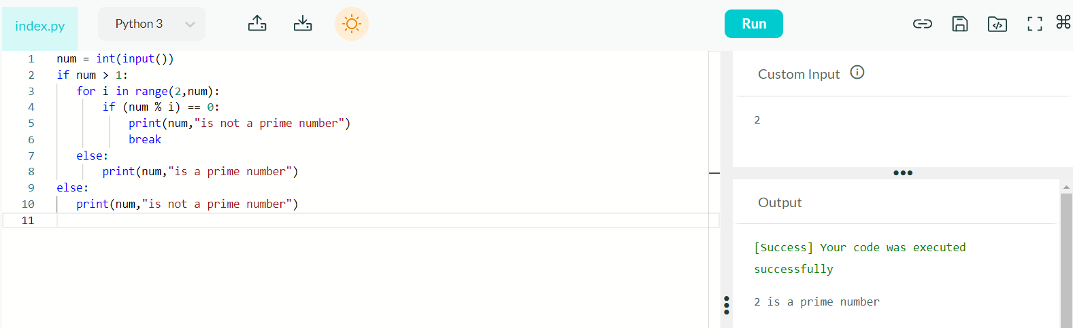

**Question-2:**

Write a program to generate odd numbers from m to n using while loop.

|  |
| --- |
| **Solution:** |
|  | n = int(input()) |
|  | m = int(input()) |
|  |  |
|  | while(n<=m): |
|  | if(n%2!=0): |
|  | print(n,end=" ") |
|  | n+=1 |
|  | n = int(input()) |

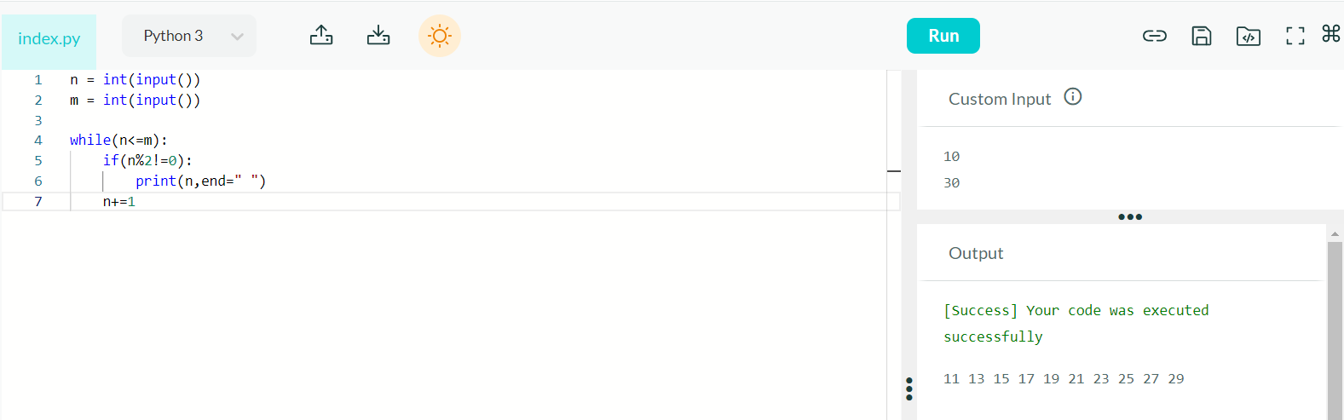

**Question-3:**

Write a Python program to display prime number series up to given number.

|  |
| --- |
| **Solution:** |
|  | num = int(input())  for n in range(2,num + 1):  if n > 1:  for i in range(2,n):  if (n % i) == 0:  break  else:  print(n,end = " ") |
|  |  |

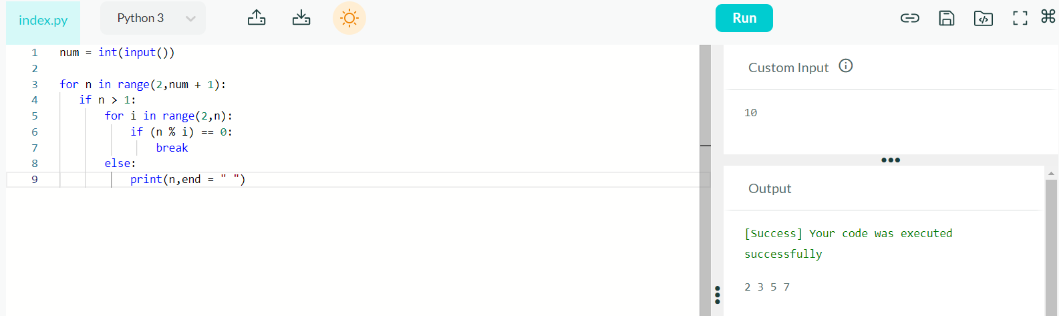

**Question-4:**

Write a Python program to generate Fibonacci series.

|  |
| --- |
| **Solution:** |
|  | n = int(input())  a = 0  b = 1  sum = 0  count = 1  while(count <= n):  print(sum, end = " ")  count += 1  a = b  b = sum  sum = a + b |
|  |  |

